Q11

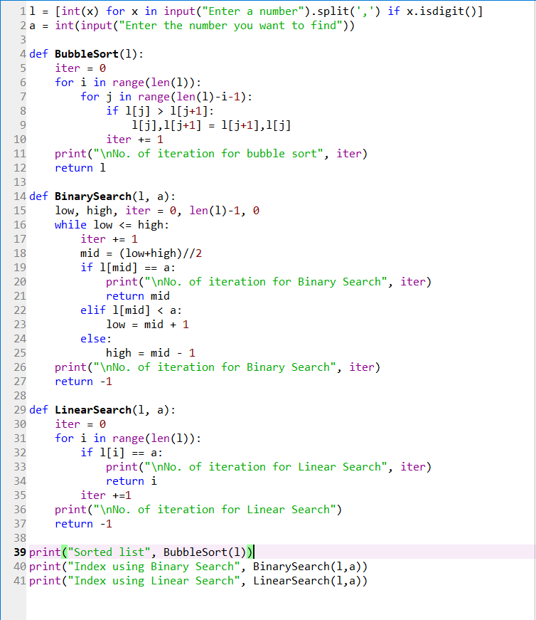**CODE**

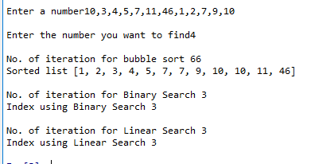**OUTPUT**

Q12

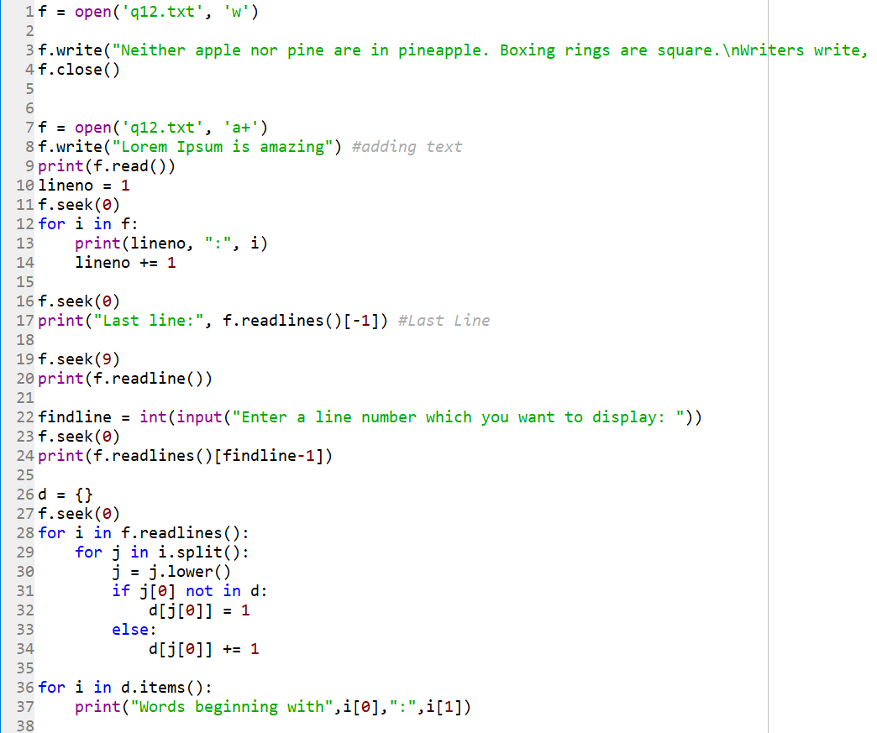**CODE**

**OUTPUT**

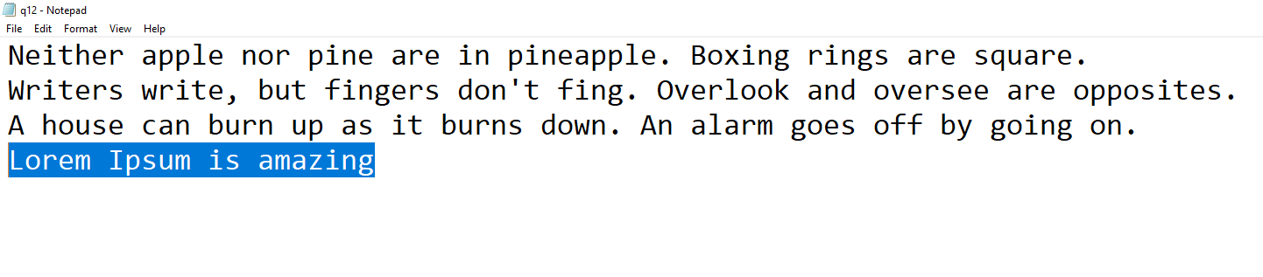

Q13.

**CODE**

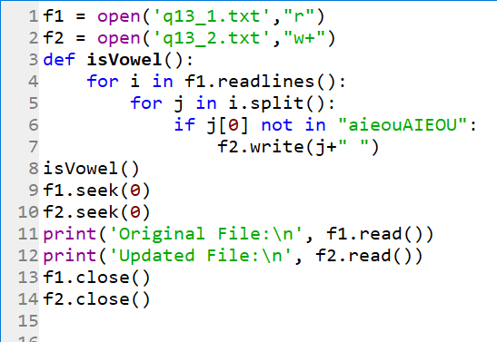

**OUTPUT**





Q14.

**CODE**

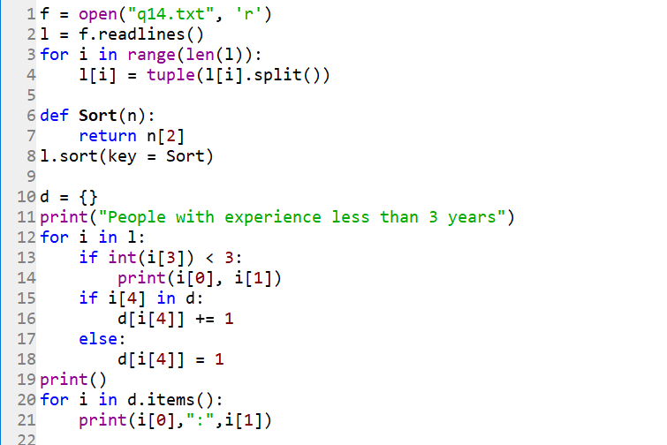

**OUTPUT**

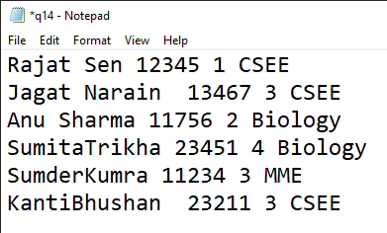

Q15.

**CODE**

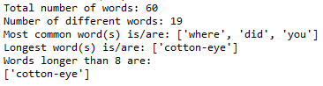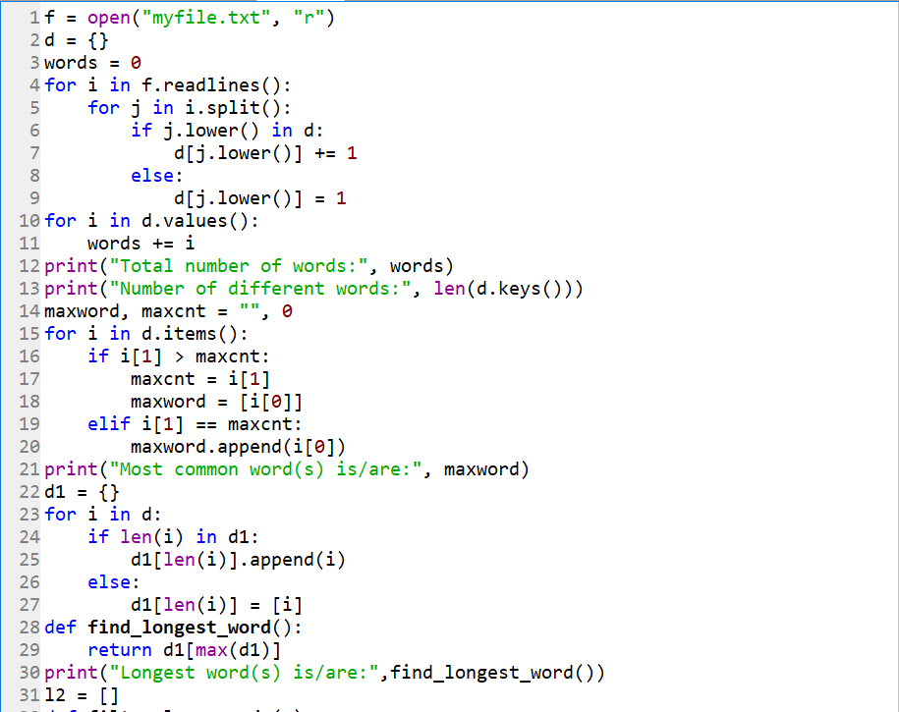

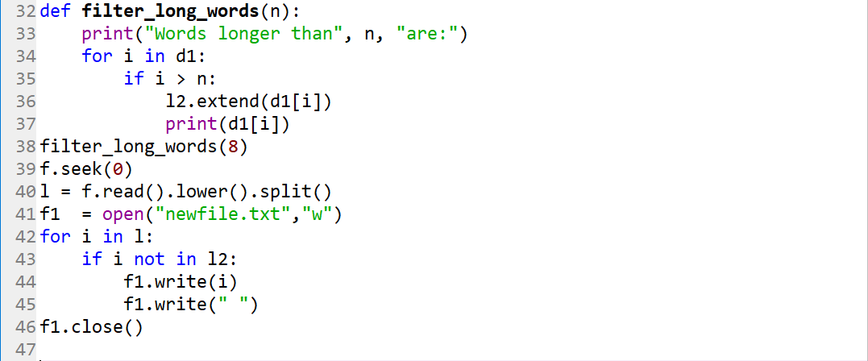

**OUTPUT**







Q16.

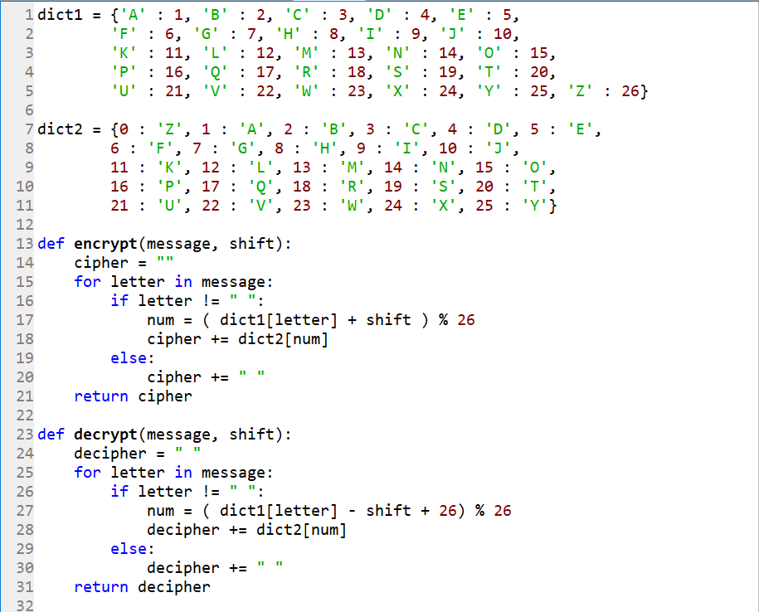**CODE**

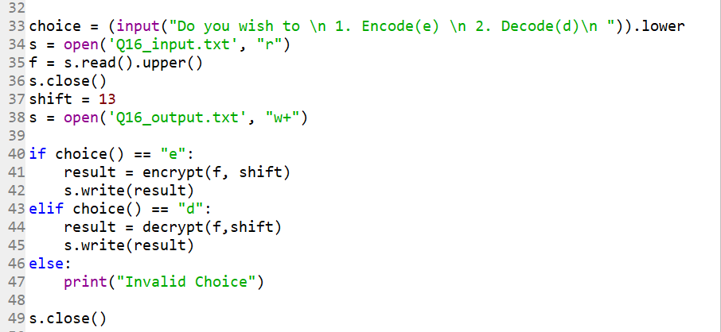

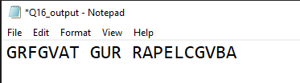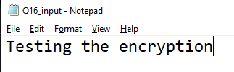**OUTPUT**

Q17.

**CODE**

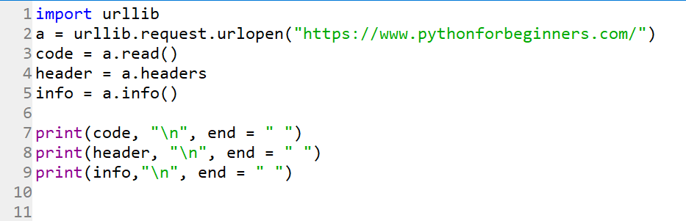

**OUTPUT**

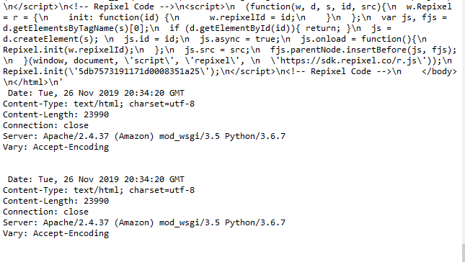

Q18.

**CODE**

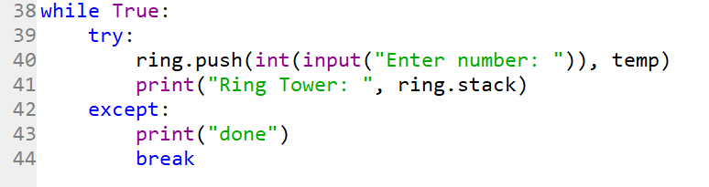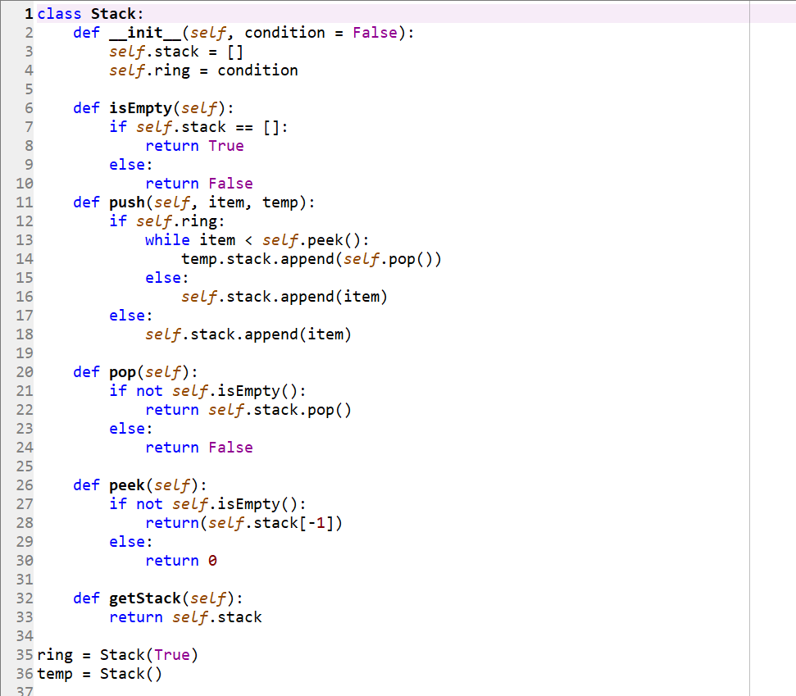

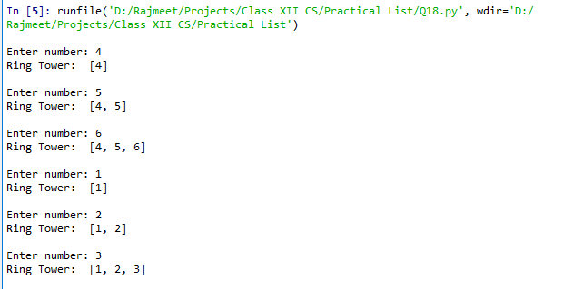**OUTPUT**



Q19.

**CODE**

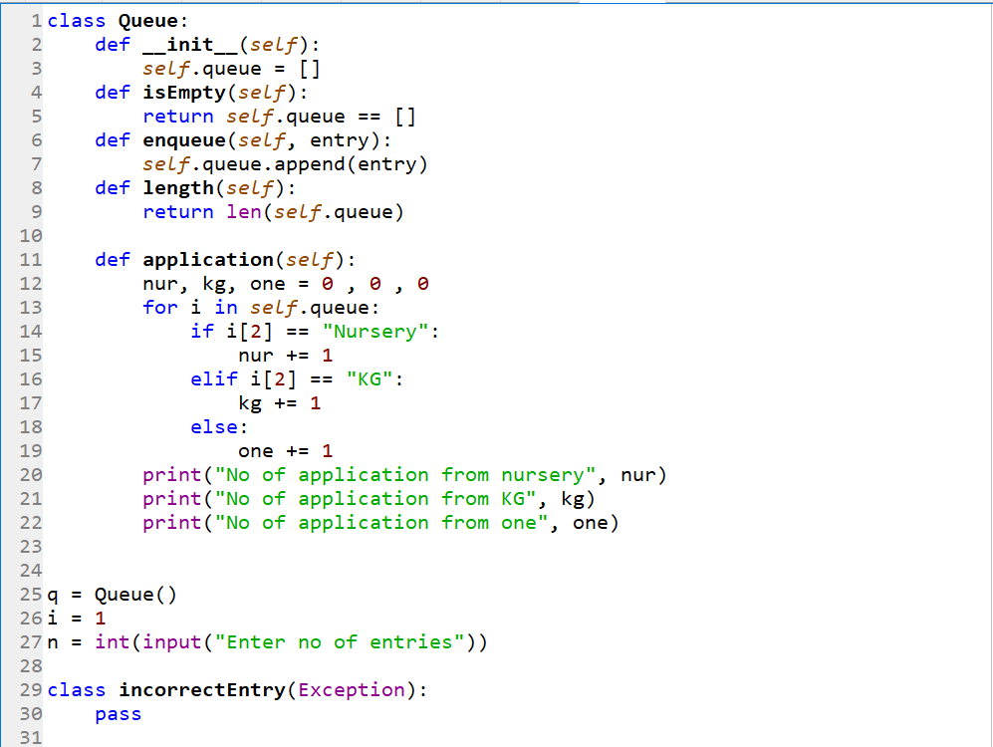

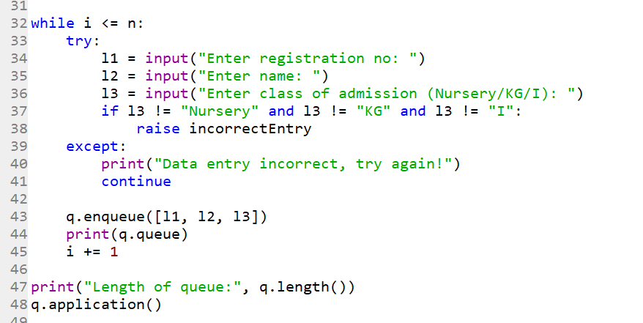

**OUTPUT**

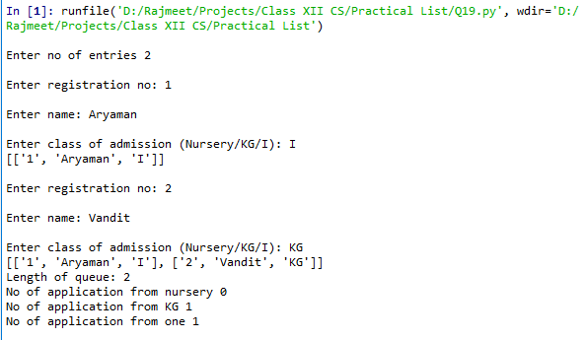

Q20_urls.py

CODE

from django.contrib import admin

from django.urls import path

from django.conf.urls import url

from . import views

urlpatterns = [

path('admin/', admin.site.urls),

url(r'^$', views.home, name='homepage'),

url(r'^page1/$', views.page1, name='authpage')

]

Q20_views.py

CODE

from django.http import HttpResponse

from django.template import engines

from django.template.loader import render_to_string

def home(request):

title = 'cal v1.0'

author ='aaa'

about_template = '''<!DOCTYPE html>

<html>

<head>

<title>''' + title + '''</title>

</head>

<body>

<center><h1>About ''' + title + '''</h1></center>

<center><p>This Website was developed by ''' + author + '''.</p></center>

<center>

<form name="cal" action="\page1" method="get">

Enter the first value

<input name="val1" type="text" value=""><br>

Enter the second value

<input name="val2" type="text" value=""><br>

Enter the Operator(+,-,/,*)

<input name="opt" type="text" value=""><br>

<input name="sbmt" type="submit" value="submit">

<input name="sst" type="reset" value="reset">

</center>

</form>

<center><p><a href="{% url 'homepage' %}">Return to the homepage</a>.</p></center> </body> </html>'''

django_engine = engines['django']

template = django_engine.from_string(about_template)

html = template.render({'title': title, 'author': author})

return HttpResponse(html)

def page1(request):

title = 'cal v1.0'

author ='aaa'

val1 = int(request.GET.get('val1'))

val2 = int(request.GET.get('val2'))

opt=request.GET.get('opt')

if opt=='+':

sum=val1+val2

about_template = '''<!DOCTYPE html>

<html>

<head>

<title>''' + title + '''</title>

</head>

<body>

<center><h1>About ''' + title + '''</h1></center>

<center><p>The sum is ''' + str(sum) + '''</p></center>

<center><p><a href="{% url 'homepage' %}">Return to the homepage</a>.</p></center>

</body>

</html>'''

elif opt=='-':

sub=val1-val2

about_template = '''<!DOCTYPE html>

<html>

<head>

<title>''' + title + '''</title>

</head>

<body>

<center><h1>About ''' + title + '''</h1></center>

<center><p>The difference is ''' + str(sub) + '''</p></center>

<center><p><a href="{% url 'homepage' %}">Return to the homepage</a>.</p></center>

</body>

</html>'''

elif opt=='*':

prod=val1*val2

about_template = '''<!DOCTYPE html>

<html>

<head>

<title>''' + title + '''</title>

</head>

<body>

<center><h1>About ''' + title + '''</h1></center>

<center><p>The product is ''' + str(prod) + '''</p></center>

<center><p><a href="{% url 'homepage' %}">Return to the homepage</a>.</p></center>

</body>

</html>'''

elif opt=='/':

quot=val1/val2

about_template = '''<!DOCTYPE html>

<html>

<head>

<title>''' + title + '''</title>

</head>

<body>

<center><h1>About ''' + title + '''</h1></center>

<center><p>The quotient is ''' + str(quot) + '''</p></center>

<center><p><a href="{% url 'homepage' %}">Return to the homepage</a>.</p></center>

</body>

</html>'''

else:

about_template = '''<!DOCTYPE html>

<html>

<head>

<title>''' + title + '''</title>

</head>

<body>

<center><h1>About ''' + title + '''</h1></center>

<center><p>Wrong operator, try again </p></center>

<center><p><a href="{% url 'homepage' %}">Return to the homepage</a>.</p></center>

</body>

</html>'''

django_engine = engines['django']

template = django_engine.from_string(about_template)

html = template.render({'title': title, 'author': author})

return HttpResponse(html)

**OUTPUT**

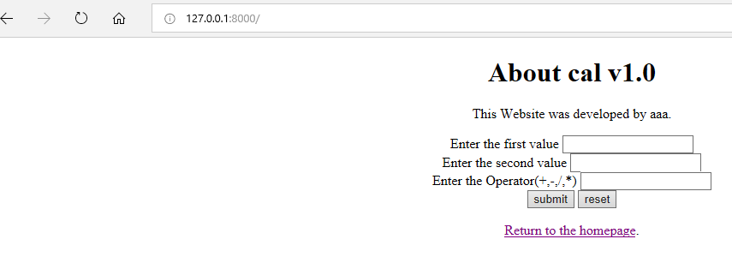

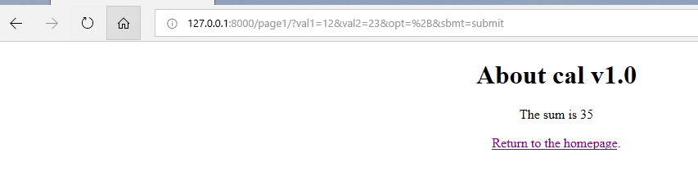

Q1. DBSQL

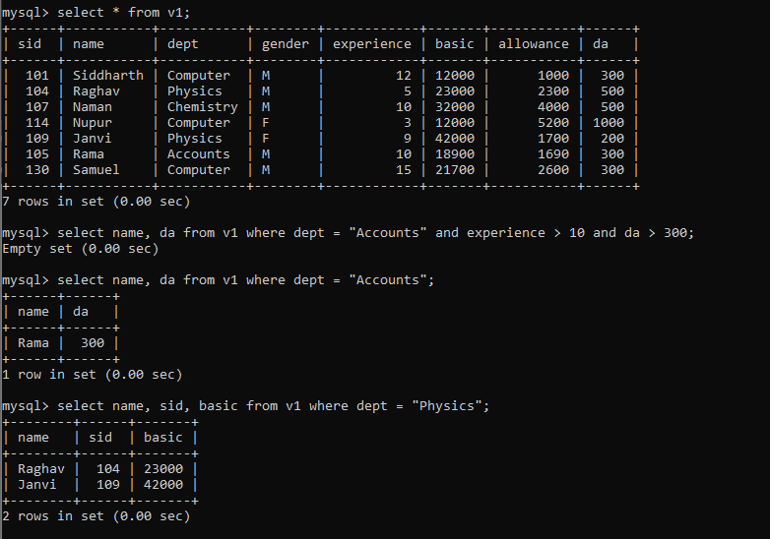A, B, C)

D)

E)

Q3. DBSQL

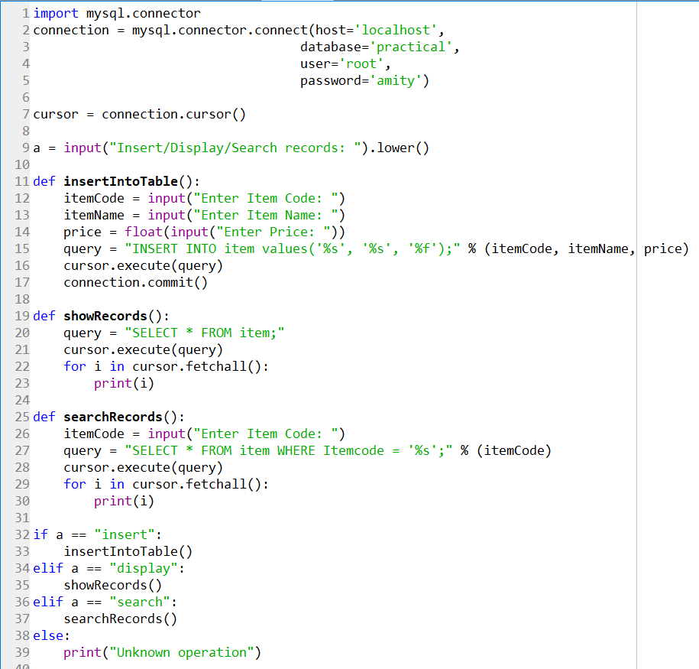**CODE**